**T05: Network Layer I**

**Q1:** A router has the following (CIDR) entries in its routing table?

|  |  |
| --- | --- |
| **Address/mask** | **Next hop** |
| 129.47.104.0/21 10000001.00101111.01101000.00000000 | Interface 0 |
| 129.47.112.0/21 | Interface 1 |
| 190.34.116.0/22 | Interface 2 |
| 129.47.192.0/19 | Router 1 |
| default Router | Router 2 |

For each of the following IP addresses, what does the router do if a packet with the following destination address arrives?

1. 129.47.85.10 first 5 bits of 1010101 (third block) = 10101
2. 129.47.110.14 first 5 bits of = 01101 = interface 0
3. 129.47.221.2
4. 190.34.119.7
5. 190.34.106.7

**Q2:** Consider the network diagram below consisting of 5 links and 3 subnets. If PC0 sends an IP packet to PC1, what are the source and destination MAC and IP addresses on each link?

CNCO2000 & CMPE2000/3000

–

Tutorial

0

5



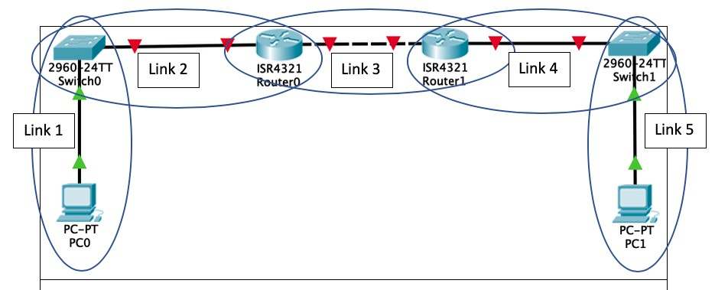

|  |  |  |
| --- | --- | --- |
|  | **MAC** | **IP** |
| PC0 | AA:AA:AA:AA:AA:AA | 10.1.1.1 |
| Switch 0 (PC side) | BB:BB:BB:BB:BB:BB | 110.1.1.2 |
| Router0 (Switch side) | CC:CC:CC:CC:CC:CC | 10.1.1.3 |
| Router0 (WAN side) | DD:DD:DD:DD:DD:DD | 10.1.2.1 |
| Router1 (WAN side) | EE:EE:EE:EE:EE:EE | 10.1.2.2 |
| Router1 (Switch side) | 11:11:11:11:11:11 | 10.1.3.1 |
| Switch 1 (PC side) | 22:22:22:22:22:22 | 10.1.3.2 |
| PC1 | 33:33:33:33:33:33 | 10.1.3.3 |

**Complete the table below:**

1 | P a g e

|  |  |  |  |  |
| --- | --- | --- | --- | --- |
|  | Source MAC Address | Dest. Mac Address | Source IP Address | Dest. IP Address |
| Link 1 | AA:AA:AA:AA:AA:AA | CC:CC:CC:CC:CC:CC | 10.1.1.1 | 10.1.3.3 |
| Link 2 | AA:AA:AA:AA:AA:AA | CC:CC:CC:CC:CC:CC | 10.1.1.1 | 10.1.3.3 |
| Link 3 | DD:DD:DD:DD:DD:DD | EE:EE:EE:EE:EE:EE | 10.1.1.1 | 10.1.3.3 |
| Link 4 | 11:11:11:11:11:11 | 33:33:33:33:33:33 | 10.1.1.1 | 10.1.3.3 |
| Link 5 | 11:11:11:11:11:11 | 33:33:33:33:33:33 | 10.1.1.1 | 10.1.3.3 |

IP doesn’t change. MAC address only changes when exiting/entering a new network. Switch-> Router

**Q3:** What is the special significance of the following addresses?

1. 0.0.0.0 unspecified address. Represents default route in context of a router. It is not assignable to an interface

In terms of webserver, 0.0.0.0 means the address of “this host”

1. this host, primary ip of the machine

2. dhcp when a unique address has not been determined yet as a source ip

3. in the context of router 0.0.0.0 represent default route. It is not assignable

1. 0.0.0.18 the host with the host id on this local network.
2. 255.255.255.255 broadcast on this local network
3. 161.115.255.255 target network broadcast 161.115.0.0/16

**Q4:** Suppose that a network with address 123.132.23.0/24 is to be split into 16 subnets. How many hosts can there be on each subnet? /24 means you cannot alter the first 24 bits.

In this case we can only modify the last 8 bits ­_ _ _ _ _ _ _ _

14 hosts on each subnet as 0.0.0.0 is network address and 1.1.1.1 is broadcast address.

**Q5:** Which of the following are valid IPv6 addresses. (Choose all those apply)?

Ipv4 32bit 4 block of 8 bit. Ipv6 128bit 8 block of 16 bit

1. ::192:168:0:1 valid.
2. 2002:c0a8:101::42 valid

CNCO2000 & CMPE2000/3000

–

Tutorial

0

5



1. 2003:dead:beef:4dad:23:46:bb:101 valid
2. :: valid
3. 2002::d01c:102::2 invalid.

2 | P a g e